MEMORANDUM
July 13, 2010

TO: Lake County Planning, Building and Zoning Committee
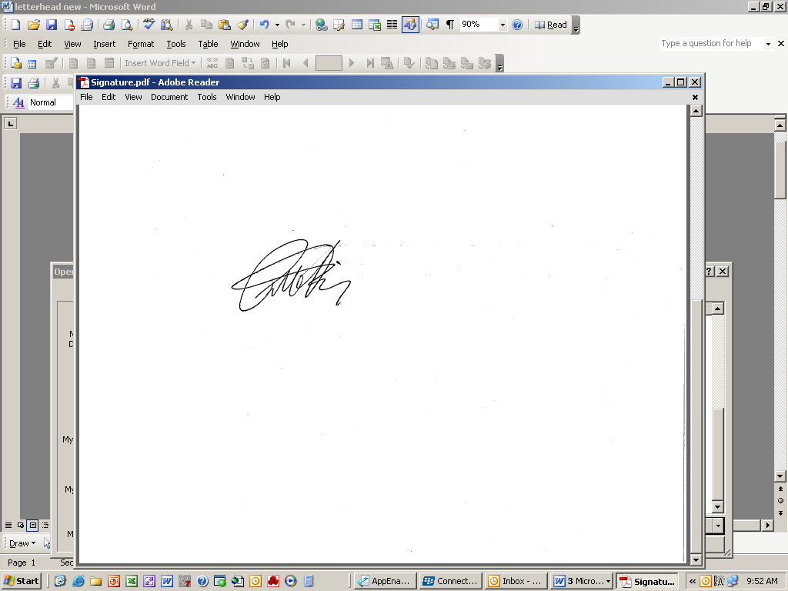
FR: Patrick S. Tierney, Principal Planner
Lake County Department of Planning, Building and Development

RE: Committee Action on Subdivision Assurance

The attached report represents the staff’s recommendation on a subdivision assurance that is scheduled for expiration. Staff has been making periodic inspections of the subdivision and has determined that extending the assurance would not negatively affect the surrounding properties or property owners in the subdivision. Staff requests the Committee’s concurrence with staff’s recommendation.

