M E M O R A N D U M
July 13, 2010

TO: Lake County Planning, Building and Zoning Committee
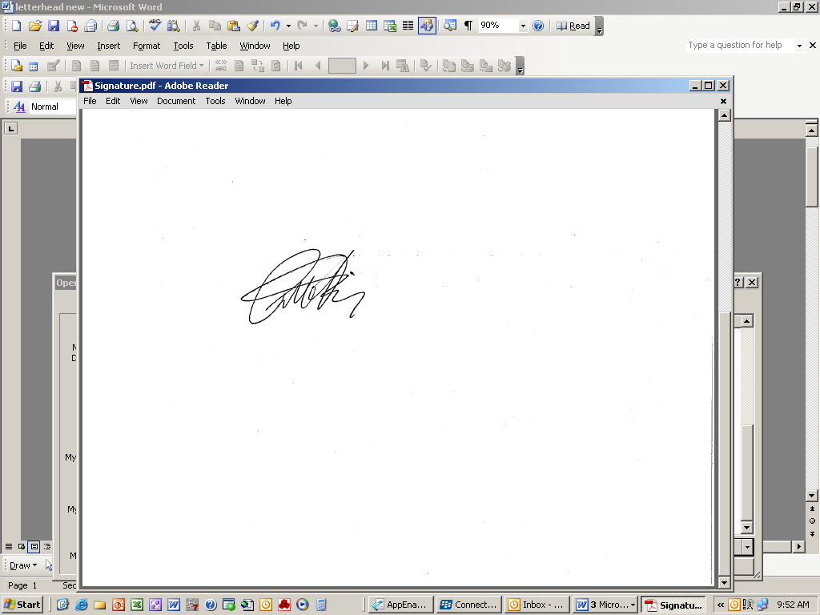
FR: Patrick S. Tierney, Principal Planner
Lake County Department of Planning, Building and Development

RE: Wanish Park PUD – Warren Township
- Request to approve subdivision agreement
- Authorization to release the cash bond to the principal
Amount: $2,293,000
Expiration Dates: Needs to be established

At the June 1, 2010 Committee meeting, staff outlined 4 alternatives that they currently use or advocate be used to assist developers in extending their assurances and/or to maintain the viability of subdivisions that have been approved but have limited current marketability. Staff intends on finalizing that report for the Committee’s consideration at an upcoming meeting. At this time, the Committee is being asked to consider a proposal by Wanish LLC consisting of an alternative of staff’s previous discussion of alternatives at the June 1st meeting.

Wanish Park PUD was approved by the Committee on April 1, 2008 and has not commenced any of the subdivision improvements. All permits, with the exception of the Site Development Permit, have lapsed. In order to temporarily obtain a release of the financial assurances, Wanish LLC has submitted a request to have the Committee temporarily suspend their original approval of the subdivision plat documents (i.e. Final Plat and Horizontal Control Plan) for a two year period. It is anticipated that economic conditions will improve and the marketability for the subdivision will be more favorable by the end of the 2-year period. The agreement being presented to the Committee has been carefully reviewed and approved by the States Attorney’s office as well as the developer’s legal counsel prior presentation to the Committee.

Summary of Agreement Terms:
- Developer is requesting that the Committee temporarily suspend their approval of the Final Plat documents (Final Plat and Horizontal Control Plan), in exchange for which the County will release the performance assurance.

- The developer agrees not to construct any of the improvements or market or sell any lots in the subdivision until the subdivision is “made whole” by satisfying the following conditions:

  - Wanish LLC provides a written notice to the Director of the Planning, Building and Development Department of the County requesting authorization to approve the Final Plat Documents. The notice will indicate that it is Wanish LLC’s desire to continue with the development of the subdivision and that the composition of the development will remain unchanged.
  - The Director will verify that the final plat documents are unchanged as approved on April 1, 2008.
  - Wanish LLC will provide evidence that all current property taxes are paid.
  - Wanish LLC will need to provide new financial assurances in acceptable form that are based on current approved estimate of costs for the subdivision improvements.

- Upon the Director’s verification that the conditions above are met, the Director will counter sign the notice and the document will be recorded in the Recorder of Deeds Office.

- All ordinances in effect when the subdivision was originally approved will remain in effect.

- A term up to July 13, 2012 establishes the deadline within which the notice will need to be received by the Director or an extension granted by the Committee. If a notice is not received or extension granted, the plat will be null and void and the property will revert to its predevelopment state.

Recommendation:
Staff recommends that the Committee approve the agreement and authorize releasing the assurance upon the recordation of the agreement.

